Directions: Draw the triangles with the given properties and solve for all missing side lengths and angle measures.
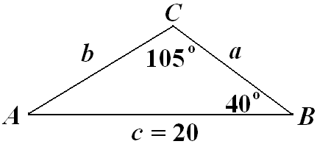

c = 45, B = 10°, C = 135°
a = 20, A = 30°, B = 45°

